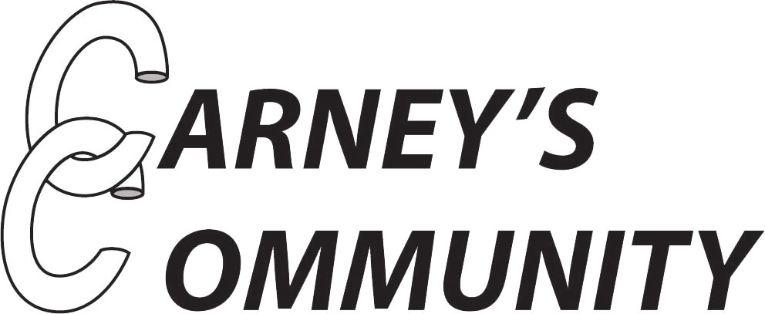

Youth Worker and Mentor
Job Description

Responsible to: Lead Youth Worker
Responsible for: One-to-one and group work
Salary: £11:05 per hour
Hours: Sessional but must be available on Monday, Wednesday and Thursday evenings from 4:45-8:15pm.

Carney’s Community’s Vision

Carney’s Community’s services are targeted at disadvantaged young people aged 11 to 30 who come from deprived backgrounds in Wandsworth, Lambeth and the surrounding areas. We aim to reduce offending, re-offending and anti-social behaviour in Wandsworth and Lambeth, whilst improving social mobility and community cohesion. Carney’s Community also aims to build the self-discipline, confidence and employability of young people as we believe this is key to reducing offending and anti-social behaviour and enabling young people to reach their full potential. Our key objectives are to engage young people in positive and constructive activities such as boxing, bike maintenance and training courses, through which our staff mentor the participants. We also provide intensive, long-term and consistent one-to-one keywork support to a number of participants identified as in need of ongoing support.

Carney’s Community’s Values

Overall, Carney’s Community believes that by empowering young people through mentoring, participation and focusing on their strengths, they can improve not only their future opportunities, but also their local communities. We believe young people have huge potential, which is why we work to create shared experiences through our activities and empower people to use their imagination to develop dreams into reality. Carney’s Community encourages action against injustice and promotes proactivity, ensuring the young people play a central part in the transformation of the neighbourhood as well as their own lives.

Job Description
The purpose of the job is to deliver youth and community provision for Carney’s Community.
Specific duties of the Youth Worker and Mentor (session based):
- Support the weekly session of activities at Carney’s Community, such as boxing, bike maintenance, cooking classes, youth club and music studio sessions.
- Support the holiday activities provided by the organisation, such as trips or youth festivals.
- Be proactive and youth-led in coming up with ideas for how to better engage young people in the organisation, particularly the target group of young people the charity aims to support.
- Work collaboratively and supportively within a team of other mentors and coaches in order to bring a united front to sessions.
- Attend briefings, de-briefings and ongoing meetings to improve practice and allow space for discussion of sessions.
- Be consistent in imposing the Carney’s Community Code of Conduct within sessions and setting clear boundaries and expectations to young people during sessions.
- Take registers during sessions, complete contact sheets following sessions and a timesheet each month. Ensure all paperwork is completed on time and sent digitally to the Admin team.

General duties
- Attend regular supervision and team meetings as agreed with line manager.
- Carry out all duties in accordance with Carney’s Community’s policies, actively safeguarding and promoting equality and seeking to prevent and overcome disadvantage, discrimination and bullying.
- Ensure that legislation relating to the health safety and protection of young people, staff and the general public is complied with at all times.
- Maintain appropriate boundaries and confidentiality with young people, staff and volunteers.
- Attend training events and undertake other professional development.
- Be fully aware of and understand the duties and responsibilities arising from your role in the organisation with regard to Child Protection procedures and the Safeguarding policies of the organisation to keep young people safe and protected from harm.
- To be fully aware of the principles of safeguarding as they apply to vulnerable adults in relation to your work role.
- To ensure that your line manager is made aware and kept fully informed of any concerns which you may have in relation to safeguarding and/or child protection
- Be a positive role model to young people during all work done at Carney’s Community and behave appropriately when out in the community in order to uphold the positive reputation of the centre.
- Complete the relevant training and development to fulfil statutory and Carney’s Community requirements (e.g. first aid and safeguarding) and be open to ongoing professional development.
- Take an active role in monitoring and evaluation activities including focus groups, questionnaires and case studies with young people.
- Carry out any other reasonable duties and responsibilities within the overall function, commensurate with the grading and level of responsibilities of the post.

If you progress towards Keywork, your role would involve:
- Develop effective one-to-one working relationships with an identified group of young people at risk and their families/carers. To provide them with intensive, individual support and mentoring. This may involve outreach, home visits and a range of other youth work strategies to engage the interest of young people and their families.
- Structure your work with each young person and develop Personal Development Plans to identify barriers to their progress. Set bespoke goals to support learning or personal development targets and action plans and conduct regular reviews with them.
- Keep in regular contact with the identified young people, through arranged appointments and informally at sessions or as and when you are able to connect with them.
- Provide them with ongoing advice, practical support and encouragement to enable them to participate in positive and constructive activities and a range of informal learning and personal development opportunities.
- Research and provide young people with basic information on the range of learning, training and career options and support services available to them, referring to specialists where necessary.
- Work proactively with other professionals in the team around the child in order to promote good outcomes for the young person.
- Support young people as they move between school and college/employer-based placements and be proactive rather than reactive to their ongoing needs.
- Advocate for the young person in order for them to stay enrolled in education or training and work as best you can to ensure they avoid becoming out of education for a long period.
- Carry out home visits and provide information and advice to the families of the identified young people.
- Maintain accurate, up to date records of case work and record with a keen eye for detail.
- Monitor young people’s progress and outcomes and supply information to relevant partners if appropriate.

Working hours may be subject to change and are based around the sometimes changing requirements and functions of Carney’s Community’s work. Reasonable notice will be given for any such changes.

Person Specification

The below experience and abilities are desirable but not essential:
- NVQ (or equivalent) qualification in Youth Work or Keywork
- One year’s youth work experience either paid or voluntary
- Experience of working with hard-to-reach groups
- A knowledge of working with young people involved or at risk of being involved in crime
- A strong interest in the local community, and a willingness to work with colleagues in order to further the positive reputation of the organisation within the community
- Experience of working closely with other sessional youth workers
- Competent with basic IT skills e.g. email, word documents
- Good verbal communication skills
- A good level of Maths and English
- Ability to work in a team along with self-motivation, perseverance and determination
- Ability to communicate at all levels and build relationships quickly
- Well organised, with good timekeeping and able to follow instructions
- Ability to support the aims and purposes of Carney’s Community
- Flexibility in working hours

Terms and Conditions

Hours: Monday, Wednesday and Thursday 4.45pm-8.15pm.
Salary: £11.05 per hour.
Pension: We will offer a workplace pension in line with the current legislation.
Training will be provided to support you in this post.
This post is offered subject to an enhanced DBS check, references and right-to-work checks.

How to apply: please send in your application form to: alex.bowles@carneyscommunity.org by Friday 15th July.

Please note that due to the volume of applications expected, only applicants who are invited to interview will be contacted.

